Media Kit
Sticky G
🎵 🎶

Sticky G is an acoustic band from Gaithersburg, MD and Lewes, DE, and has been performing in the Mid-Atlantic States and DC Metro since 2014. Sticky G performs at area events such as Rockville Science Day, City of Gaithersburg, summer concert series, farmers markets, community events, local restaurants, and the National Park Service. Music features family-friendly covers from classic acoustic rock, as well as specialty concerts including Christmas, St. Patrick's Day, and Halloween. Sticky G is comprised of key members from Maryland, Washington, DC, and DE, with occasional appearances from guest artists.

The band and our music –

- 3-6 musicians, depending upon venue (guitar, mandolin, banjo, concertina, bass, percussion, drums, Irish flute, harmonica, vocals)
- Covers from classic acoustic rock, rock & roll, and folk - Dylan, Creedance Clearwater Revival, Eagles, Lumineers, Traveling Wilburys, Beatles, Pure Prairie League, Steve Wynwood, Spencer Davis Group, Paul Simon, Everly Brothers, Proclaimers, Jimmy Rogers, Dolly Parton, Rolling Stones, Queen, Kathy Mattea, Dierks Bentley, Grateful Dead, Elle King, The Band, Leonard Cohen, Lykke Li, Suzanne Vega, Pete Townsend, Jimmy Buffet, and other well-known standards. Everyone will recognize the music.
- Specialty concerts include Christmas, St. Patrick’s Day/Irish music, Halloween.
- Concerts generally run two hours up to six hours.

Prior Events and Bookings –

- National events
  - National Cherry Blossom Festival
  - President’s Park on the Ellipse/White House – Christmas concert
  - Wolf Trap Center for the Performing Arts – Move with Music Festival
  - Other National Park Service events
- Delaware events
  - Schell Brothers Governors, Coastal Club, summer concerts
- Virginia events
  - Fort Hunt Summer Concert Series (National Park Service)
  - Porto Vecchio Condominium Christmas and Labor Day parties
- Maryland events
  - Maryland Parks - Montpelier Mansion Spring and Herb Festival
  - Kentlands Under the Lights at Market Square
  - City of Gaithersburg Christmas and Halloween events, Oktoberfest
  - Barking Mad Cafe Summer Concert Series
  - Montgomery County Fair
  - Central Farm Markets, Milk Lady Market, Olney Farmers & Artists Market
- Other events include: happy hours, restaurants/bars, wineries, bar-b-ques, private parties, charitable events

Contact Information and bookings:

Karen Norris, Booking Agent
301-613-1277 (mobile)
5678karen@gmail.com

Facebook
https://www.facebook.com/groups/913716089507578/

Sticky G
🎵 🎶

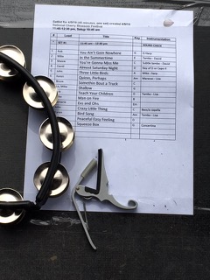 | 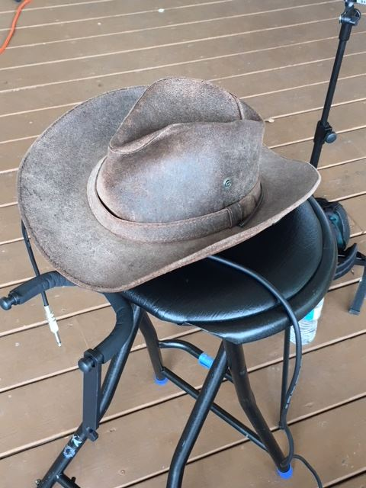 | 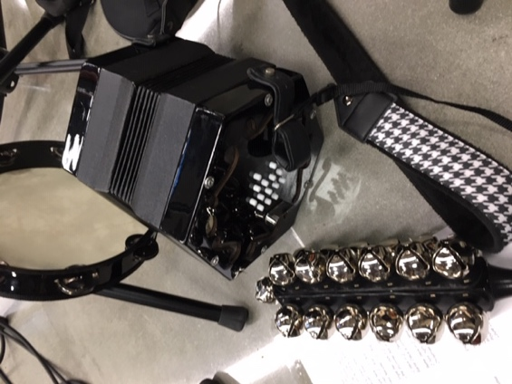

For additional information, please contact:

Karen Norris, Booking Agent
301-613-1277(mobile)
5678karen@gmail.com

